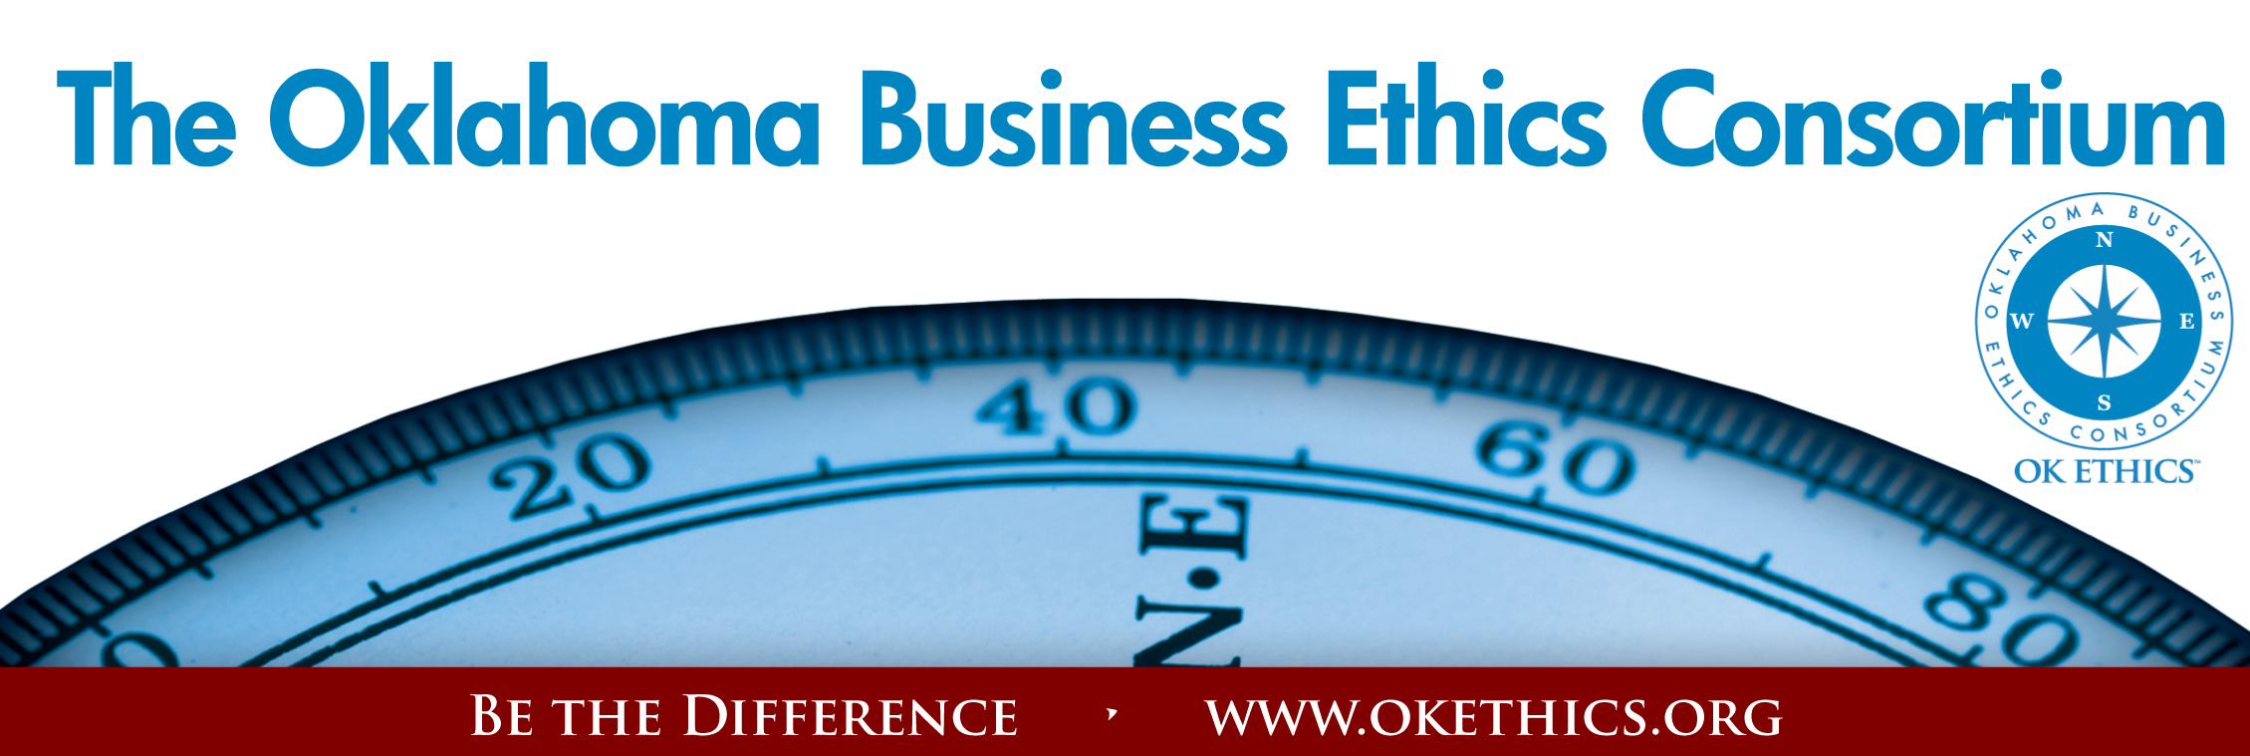

Agenda ~ Oklahoma City Chapter
February 11, 2009

I. WELCOME & INTRODUCTIONS Shannon Warren, Founder
Oklahoma Business Ethics Consortium

II. KUDOS
“As we express our gratitude, we must never forget that the highest appreciation is not to utter words, but to live by them.”
- John F. Kennedy
Registration Team:
Greg Byers of Sinclair Broadcasting Group – Registration Chair
Mary Kay Huggard & the Principal Technologies team, including
Ashley Warne, Holly Carattina, Jennifer Hicks, Kara Stevi and Becky Estes.
Deborah Gavula – OK Ethics Administrative Support

Name tags & AV:
- Joshua Jantz – Institute of Basic Life Principles

Volunteers Needed for Upcoming Events:
- Ushers
- Greeters
- AV Back-up
- Compass Awards
- Program presenters for August Symposium
Want to help us grow? Please contact
Shannon Warren at warrenokla@cox.net or call 858-2233

Speaker Gifts:
Alisa Hall –
The Stiletto Advantage

CPE Certificates:
Colin Autin –
Oklahoma Accountancy Board

Photocopies:
- Linda Manaugh & Trish Potter Metro Technology Centers (Handouts)
- Bobby Redinger -
Cole & Reed (Agendas)

Ethics of Excellence
(Booklet Donations):
- Nextep, Inc.

- OK ETHICS FOUNDATION UPDATE:

Statewide Student Ethics Challenge – Saturday, April 4

Student Chapter Mentors:
▪ Joe Walker, Grant Thornton = UCO ▪ Andrea Kesterson, Boeing = SNU

Mentors Needed for:
OCU, Rose State & Langston

To volunteer, please call Bob Byrne at Boeing: 226-5060; or Pam Fountain at Principal Technologies: 858-8800

- Speaker Introduction
Janice Dobbs – Devon Energy; Founding Member, OK Ethics Board of Directors

- Keynote Speaker
Donna Miller, Executive Resource Center, LLC
“Swimming Naked: Bold Truths for Bad Times”

VI. UPCOMING EVENTS Shannon Warren, Founder, OK Ethics

Advance reservations required for all events ~
Visit our website at www.okethics.org or call 889-0498;
Member discounts apply regardless of location.

MARCH EVENT RECOMMENDED FOR 1 CPE IN ETHICS
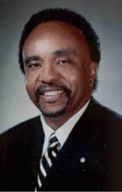
March 11
Clifton Taulbert,
President of The Building Community Institute
Author, “Eight Habits of the Heart”
Taulbert is one of America's leading thought-leaders on the "Power of Community" and views community in the workplace as a powerful leadership asset. Taulbert, a Pulitzer nominated author speaks throughout the world on the critical issue of building community based on a set of emotionally satisfying relationships branded by Respect, Affirmation and Inclusion.

Taulbert is also the author of the internationally acclaimed book, Eight Habits of the Heart, a book that provides the framework on which to build, maintain and sustain a powerful, effective and caring Community. He believes the Eight Habits of the Heart are essential for developing leadership and he conveys this message to audiences around the world.

April 29 – OU Coach, Sherri Coale –
OK Ethics Statewide Compass Awards (OKC)

To be held at the new
Oklahoma Sports Hall of Fame & Jim Thorpe Museum

WWW.OKETHICS.ORG
Tulsa Chapter Events:
- February 26 Robyn Ewing, The Williams Companies –
Core Values & Corporate Responsibility: 100 Years of History
- March 26 Panel Discussion – Generations in the Workplace

- COMPASS AWARD – NOMINATIONS SOUGHT
Turn in a nomination form found on the center of your table or give us your business card with a nominee’s name on the back. Letters go out this week!

Past Compass Award Recipients Include:
2008: BKD, LLP ~ Ideal Homes of Norman ~ Principal Technologies, Inc.
2007: Boeing ~ The Bama Companies, Inc ~ Coppermark Bank ~ Nextep, Inc.
2006: Eide Bailly ~ Valir Health

- OTHER RELATED PROGRAMS:

CPE CERTIFICATES WILL BE ISSUED AT THE
BACK OF THE ROOM
AT THE CONCLUSION
OF THIS EVENT

YOU MUST BE REGISTERED ON OUR ATTENDANCE LIST TO RECEIVE A CERTIFICATE
NOTE THAT WE WILL NOT EMAIL THESE

Character First Institute:
OK Ethics is honored by our friendship with the
Character First! Institute.
They provided wisdom and the basis for our Guiding Principles.
For more information on upcoming Business and Community Leaders' Luncheon, please contact them at 815-0001, or visit www.characterok.org./
Cost is $10 per person. The next topic is
“Sincerity in the Workplace” to be presented on
Tuesday, February 24 or Thursday, February 26.

PLEASE HELP US CONTROL COSTS BY LEAVING YOUR NAME TAG HERE

